

***Title of your article in English language for one or more lines of text, font size 16, empty line 8***

***Title of your article in Russian language, if the article***

***is written in this language***

***Name Surname1, Name Surname2 font size 11***

***Abstract: (if the article is written in English language)***

*Abstract, Keywords and ACM Computing Classification system are written in English language. Abstract range is up to 15 lines of text and recommended structure is this: scientific goal, methods, results, conclusions. Font size 10.*

***Extended Abstract: (if the article is written in Russian language)***

*First part of abstract is up to 15 lines of text and recommended structure is this: scientific goal, methods, results, conclusions. Font size 10.*

*(Add* ***Keywords*** *and* ***ACM Computing Classification System*** *(see below) here)*

Second part of abstract is about one page in length, or at your decision, normal printing characters, where all figures, tables etc. in the article are commented in English in this way: …(fig.1) …(tab.1) and the main contribution/principle/goal/message of the article is explained.

***Keywords:***

*Write 3 – 6 keywords.*

(insert Page Break at end of each page)

(two blank lines)

***ACM Computing Classification System:***

*Write a suitable set of classification names selected from the list:*

*http://www.acm.org/publications/class-2012.*

***Aбстракт: (if Russian language is used)***

*Abstract in Russian language, if used.*

***Kлючевые слова: (if Russian language is used)***

*Keywords in Russian language, if used.*

**Introduction (all the rest of article in English or Russian language)**

Scientific contribution is reviewed by two reviewers and the recommended number of pages is approximately 10 pages. Information contribution has recommended number of pages 1–5.

We receive contributions containing theoretical or practical knowledge of the information technology applications in technology, economy, law, enterprise, media, psychology, education, public administration, etc. The language of contribution is English or Russian. Our journal is issued twice a year. Send your contribution in electronic form only, using doc/docx format.

Titles of chapters have font size 13. Text of chapters has a font size 10. Subchapters (subtitle font size 10) are numbered 1.1 and 1.1.1 Times Roman Font, single spacing. Do not number the pages. Your contribution should contain at least following parts:

- Abstract

- Keywords

- ACM classification

- Introduction

- state of art concerned to your topics

- design of research (object, goal, hypothesis, methods of validation, models

and data, evaluation) or design of application (object, goal, technology-software,

data, evaluation, experiences)

- discussion of results, recommendations or external links to details

- Conclusion of main contribution

- Acknowledgement

- References

(insert Page Break at end of each page)

(two blank lines)

**1. The title of first chapter**

Here to place text of the first chapter. Every reference should be cited in text, in this way: [3]. Each reference is written in the language of its origin. In the case the reference material is translated from English, add the reference of origin, if possible.

When using formulas, they are centered, in form of written text or entered picture. When the formulas are referenced in text, they should be numbered in this way:



(1)

Titles of pictures/graphs are written below the pictures: Fig.1. Titles of tables are written on the top of tables: Table 1. References in text to pictures and tables are mandatory and they are written in this way: (fig.1) (tab.1). When using the tables or pictures/graphs, they are centered and the source should be mentioned. Printed version of this journal is black and white only - make all pictures light, sharp and contrast. Online journal keeps color contents. Pictures with many details are recommended to have maximal width of the whole text column.

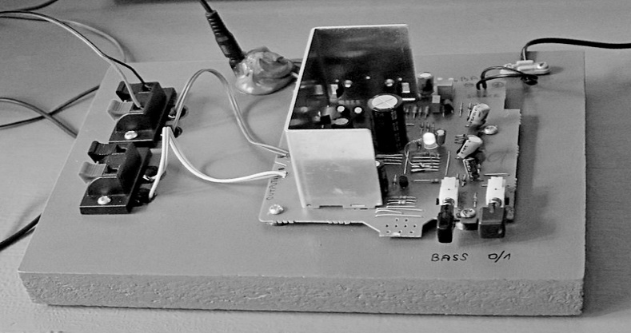

Fig.1. Title and short description of the picture (source:)

**Conclusion**

Text of conclusion.

**Acknowledgement**

Not to forget contributors, donors and the Project.

(insert Page Break at end of each page)

(two blank lines)

**References**

|  |  |
| --- | --- |
| [1] | References are written here into table layout without borderlines, font size 11.  At the end of page the table is to split, or we will do it at final process. |
| [2] | Korn, A., Korn, M. (2000). *Mathematical Handbook for Scientists and Engineers.* Dover Publications. 1152 p, ISBN 978-0486411477 |
| [3] | Surname-1, X.,Y., Surname-2, X. (2017). Title of article or contribution.  *Title of journal or collection.* vol.1, no.1, p.1-10, ISSN 12345678, doi: 12.345… |
| [4] | Name (2017). Title of webpage or material.  Retrieved June 13, 2017, from http://webpage.address.abc/xyz.pdf |

………………………………………………………………………………………

**Prof. Name-1 Surname-1, PhD.**

Institution/body/company, City, Country

name-1@address-1.abc

**Prof. Name-2, Surname-2, PuDr.**

Institution/body/company, City, Country

name-2@address-2.abc

(insert Section Break here at the end of document)